NAMA : HERY TUA SIGALINGGING

NPM : 232310030

JURUSAN : TEKNOLOGI INFORMASI

KELAS : TI-23-PA1

MATKUL : LAB. ALGORITMA PEMROGRAMAN DAN STRUKTUR DATA

TUGAS PERTEMUAN 11 STRUCTURE

1.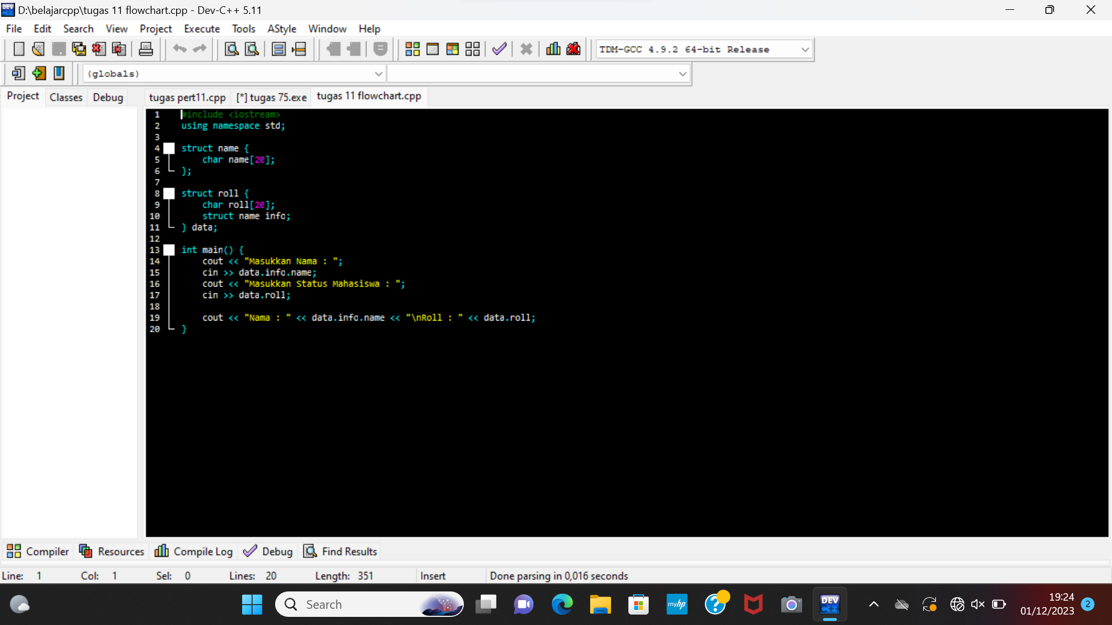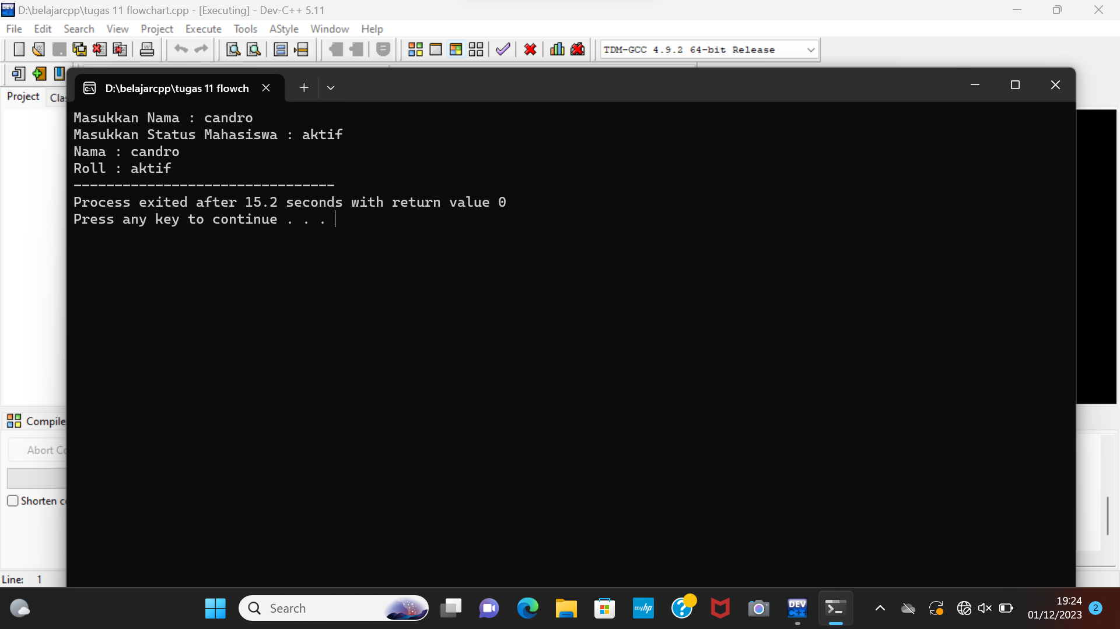

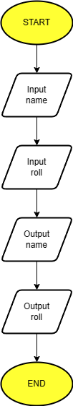

2.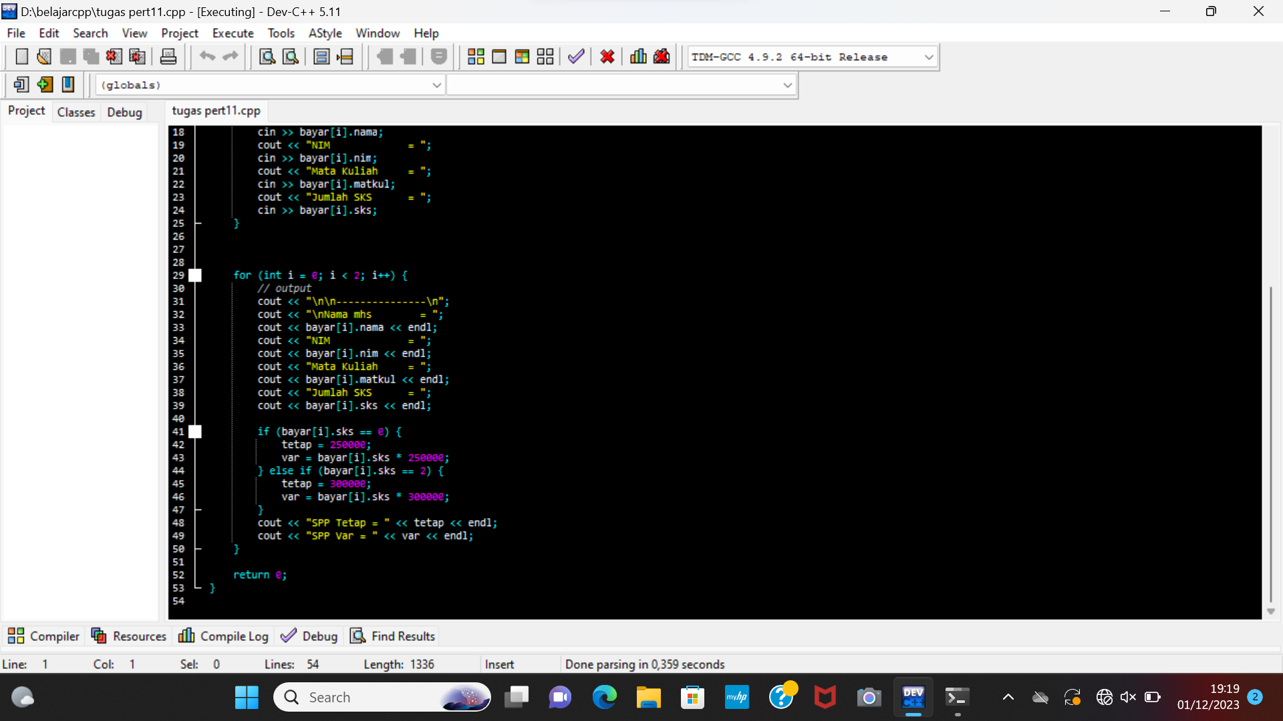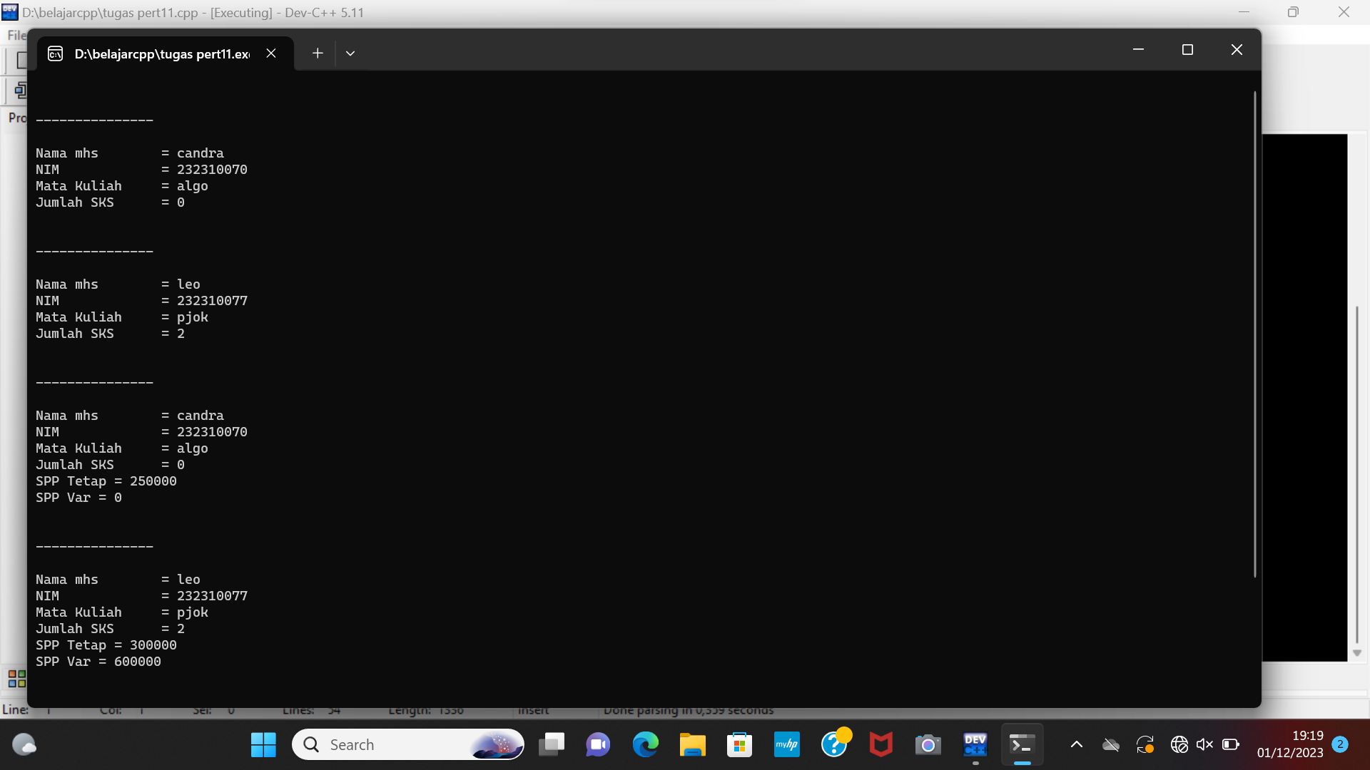

1.#include <iostream>

using namespace std;

struct name {

char name[20];

};

struct roll {

char roll[20];

struct name info;

} data;

int main() {

cout << "Masukkan Nama : ";

cin >> data.info.name;

cout << "Masukkan Status Mahasiswa : ";

cin >> data.roll;

cout << "Nama : " << data.info.name << "\nRoll : " << data.roll;

}

2.#include<iostream>

using namespace std;

struct mhs {

char nama[20], nim[10], matkul[15];

int sks;

};

mhs bayar[2];

int main() {

int tetap, var;

for (int i = 0; i < 2; i++) {

// Input data

cout << "\n\n---------------\n";

cout << "\nNama mhs = ";

cin >> bayar[i].nama;

cout << "NIM = ";

cin >> bayar[i].nim;

cout << "Mata Kuliah = ";

cin >> bayar[i].matkul;

cout << "Jumlah SKS = ";

cin >> bayar[i].sks;

}

for (int i = 0; i < 2; i++) {

// output

cout << "\n\n---------------\n";

cout << "\nNama mhs = ";

cout << bayar[i].nama << endl;

cout << "NIM = ";

cout << bayar[i].nim << endl;

cout << "Mata Kuliah = ";

cout << bayar[i].matkul << endl;

cout << "Jumlah SKS = ";

cout << bayar[i].sks << endl;

if (bayar[i].sks == 0) {

tetap = 250000;

var = bayar[i].sks \* 250000;

} else if (bayar[i].sks == 2) {

tetap = 300000;

var = bayar[i].sks \* 300000;

}

cout << "SPP Tetap = " << tetap << endl;

cout << "SPP Var = " << var << endl;

}

return 0;

}